Group Name: Ko Dev Cmp

Project Title: GPA Calculator

CMP 202 PROJECT

Mwantok Kwoopnaan Danladi BHU/22/04/05/0098

Ezra Habila Kambai BHU/22/04/05/0132

Adamu Abraham Oiza BHU/22/04/05/0113

Iwaula Chimarisa Hope BHU/22/04/09/0061

Ubah-nduka David king BHU/22/04/05/0078

Project Description and Screenshots

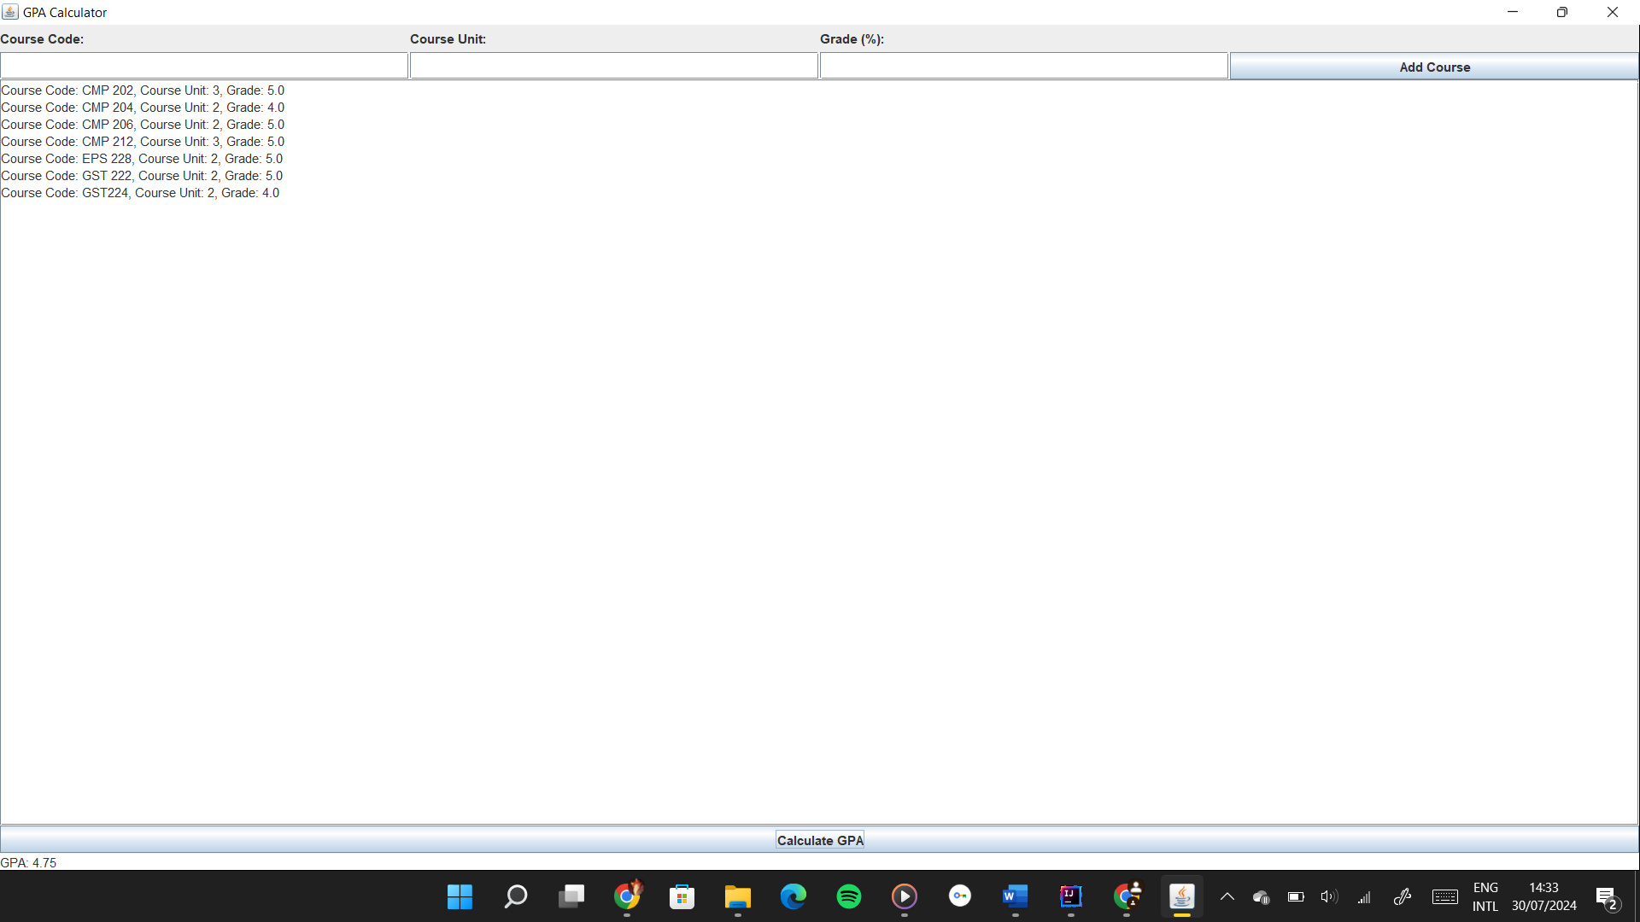

We have created common GPA calculator Mwantok Kwoopnaan BHU/22/04/05/0098

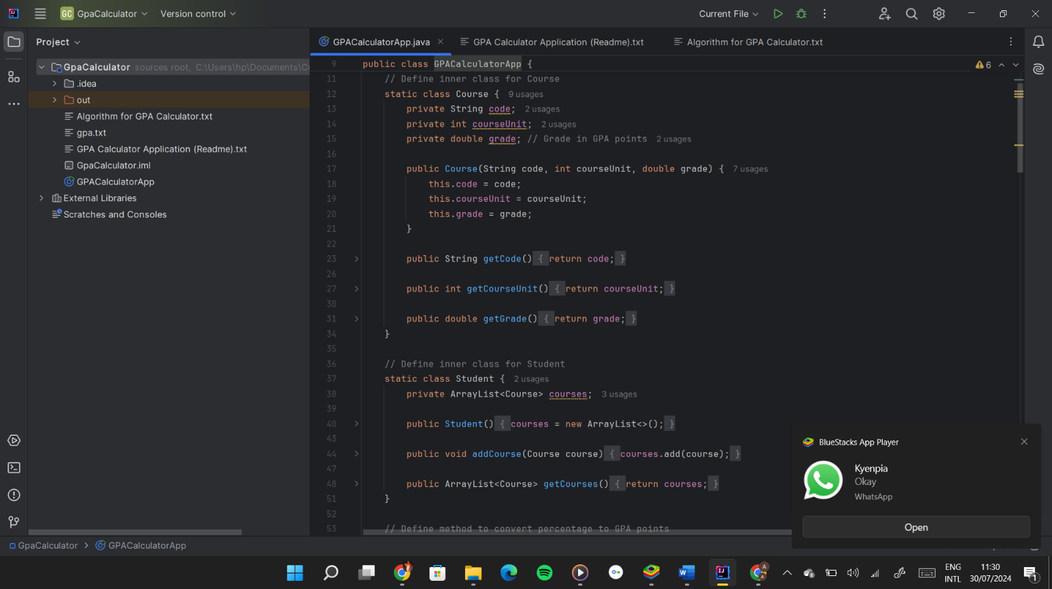

Adamu Abraham Oiza BHU/22/04/05/0113

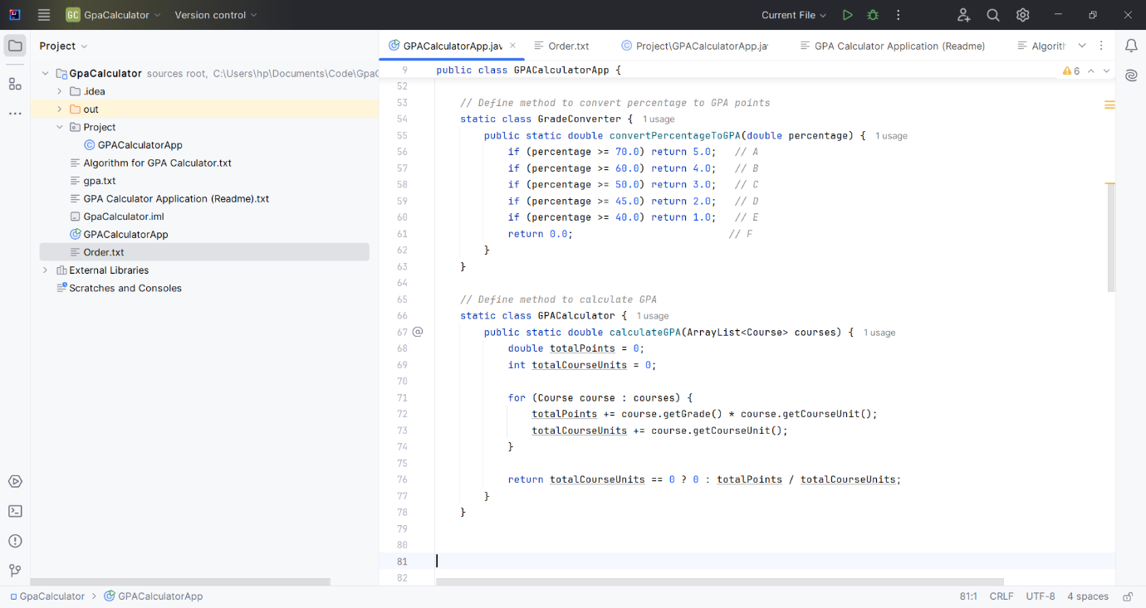

UGBAH-NDUKA DAVID KING BHU/22/04/05/0078

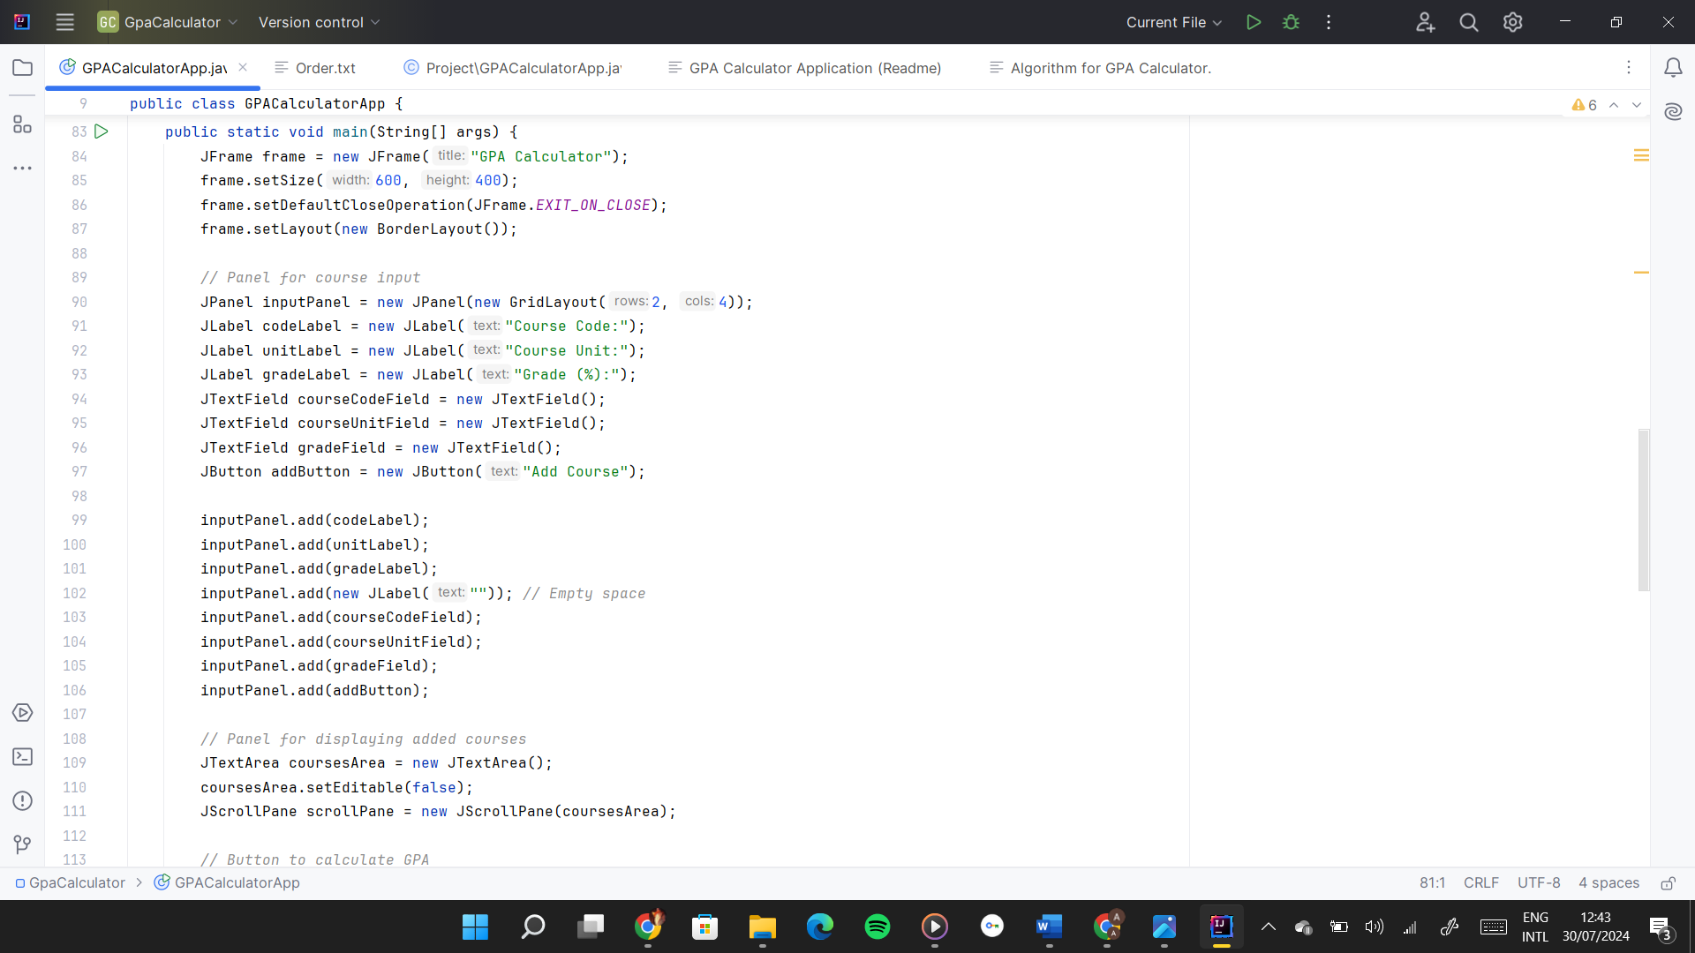

EZRA HABILA KAMBAI BHU/22/04/05/0098

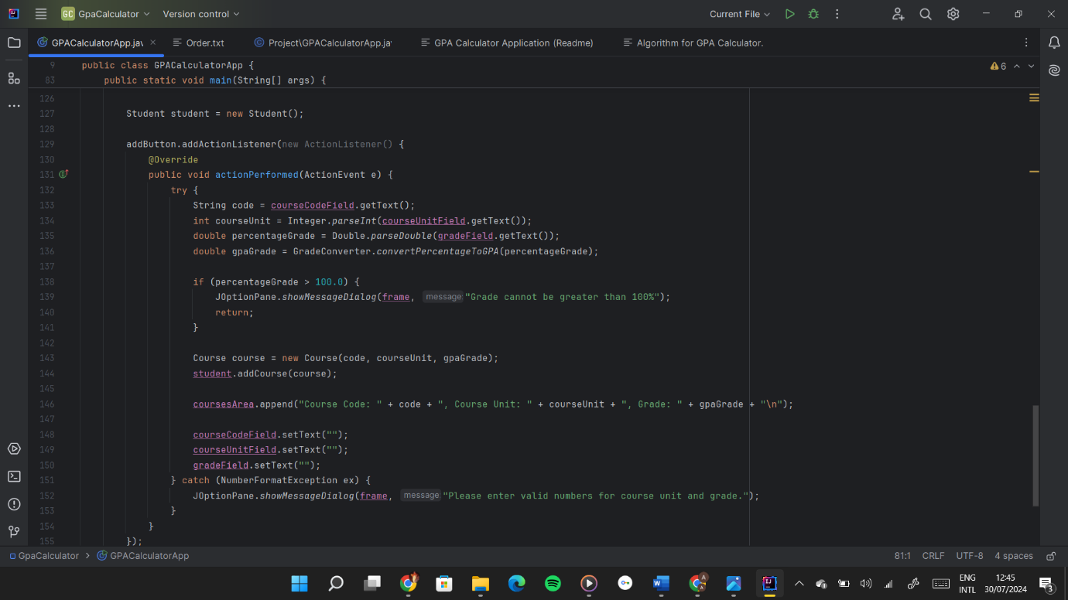

IWUALA CHIMARISA BHU/22/04/09/0061

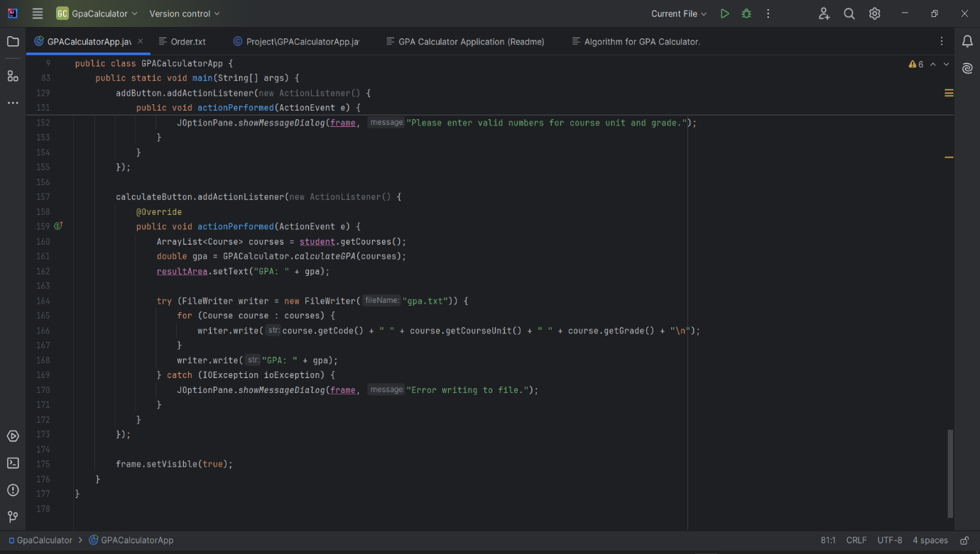

Screenshot of GitHub Contribution Page for the project

